* Database Module 10_3
  + Charlie Group
    - Jacob Breault
    - Cameron Frison
    - Skyler Millburn
    - Angela Perkins
    - William Silknitter III

**Outland Adventures**

1. ORD:

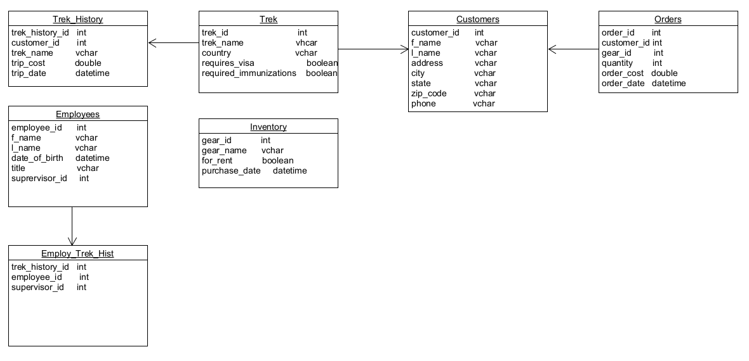

1. Screenshots:
   1. Tables created

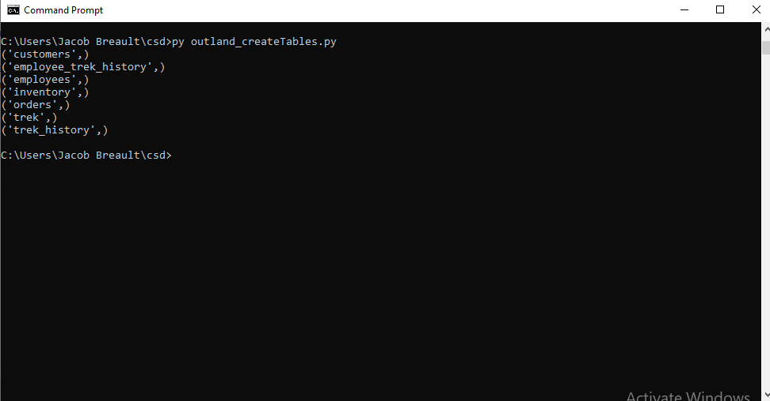

* 1. Trek table

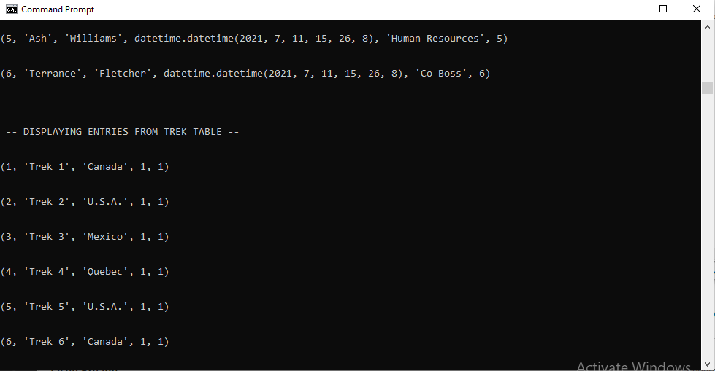

* 1. Customers table

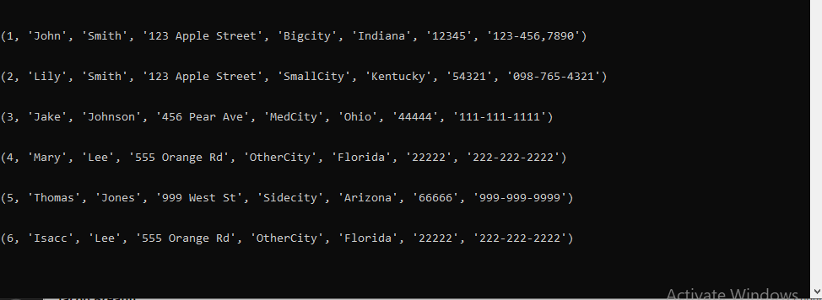

* 1. Employee Table

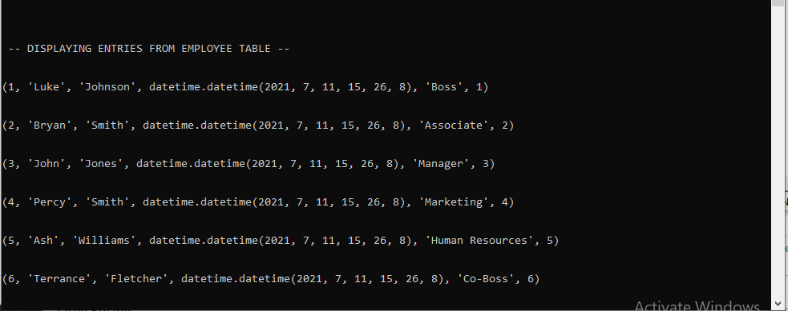

* 1. Inventory Table

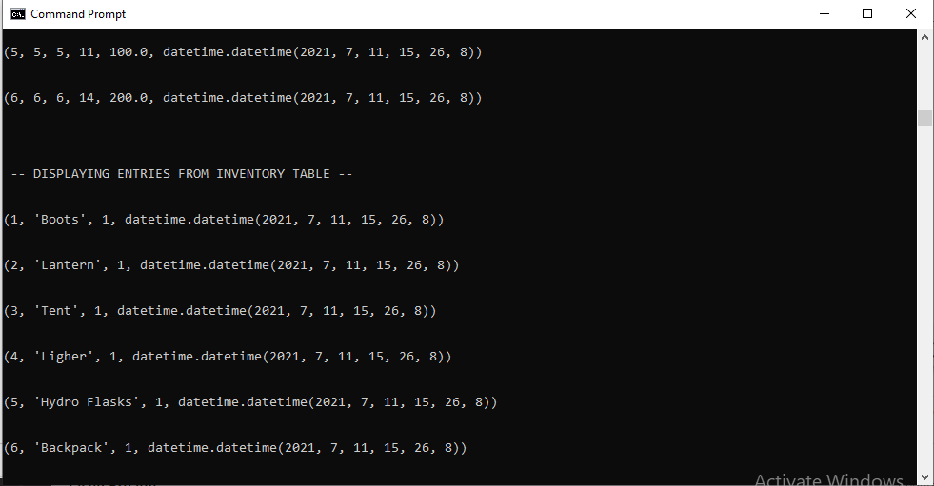

* 1. Order table

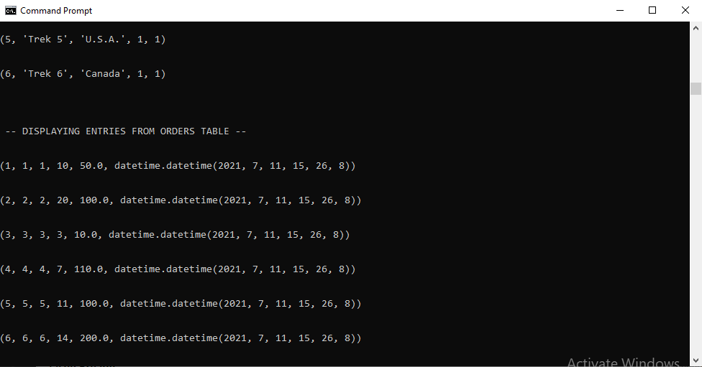

* 1. Trek History Table

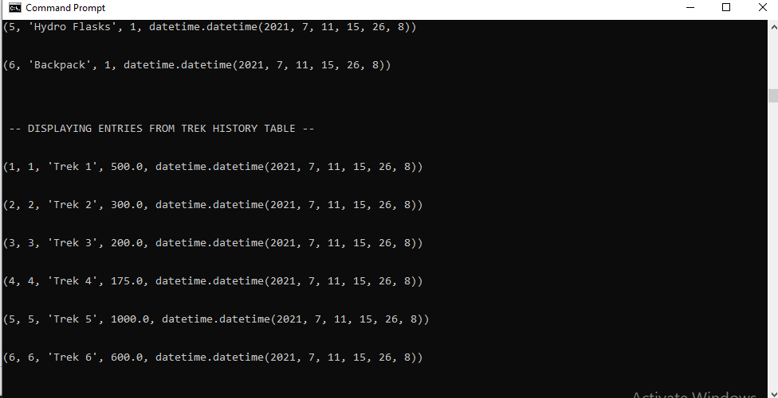

* 1. Employee Trek History Table

